**Cherry-pick**

* As shown in the below image we would like to have one commit (in blue) created in branch v2.0 to be added to v1.0 as it is important fix. 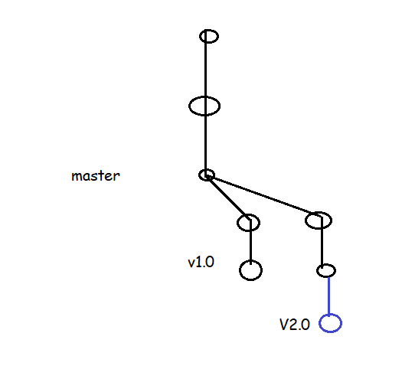
* Post Cherrypick

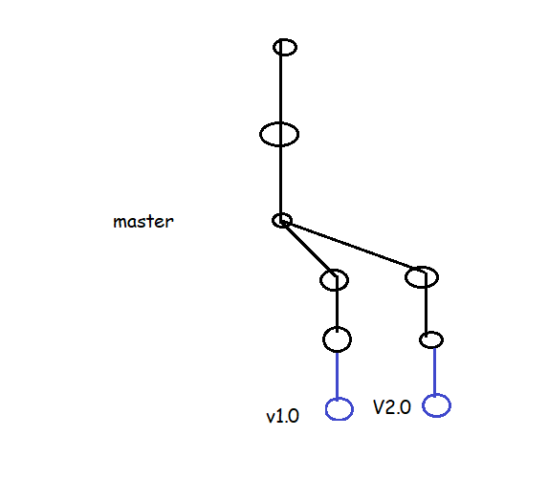

**Rebase-** it is for maintaining linear history of commit.

* As shown in the below image we have made changes in the master branch and we want those changes in the v1.0 and v2.0 branches 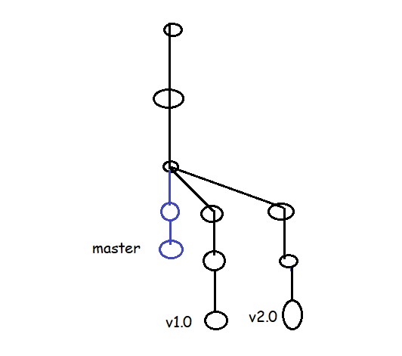
* After rebasing

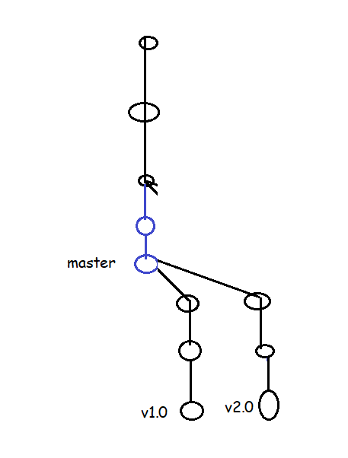

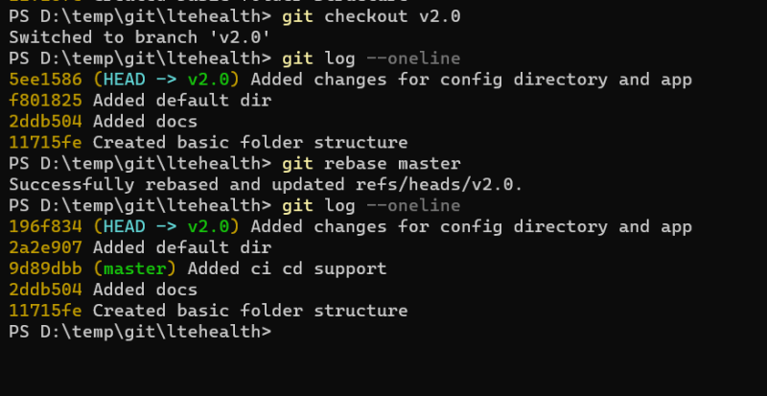

**Some Useful Commands**

* View history of last n commits

git log -n

git log -3

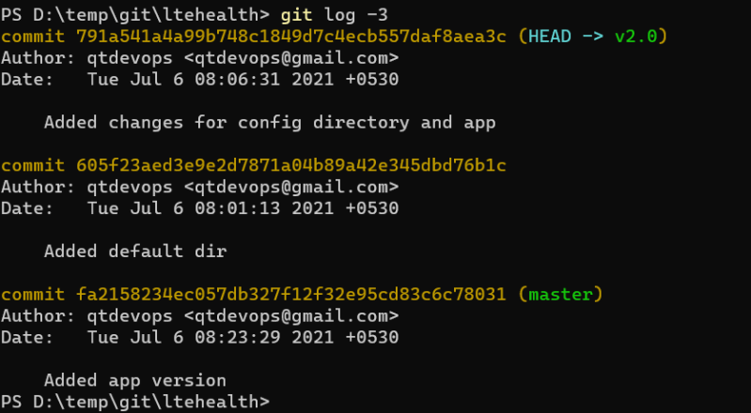

* View the graph

git log --decorate --graph --oneline --all

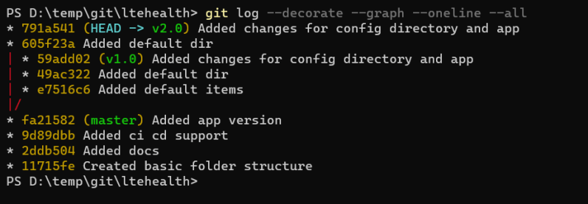

* Search commit by message

git log --grep "expression"

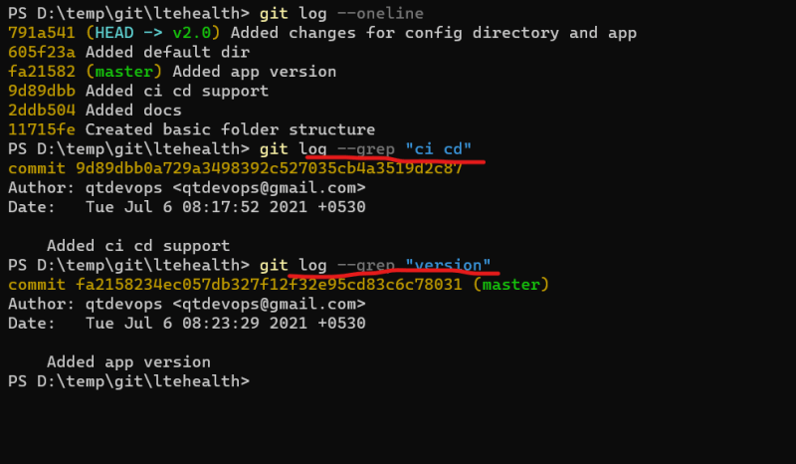

Viewing the differences b/w any two commits

git diff <commitA>..<commitB>

git diff <branchA>..<branchB>

git diff --name-only <commitA>..<commitB>

git diff --name-only <branchA>..<branchB>

